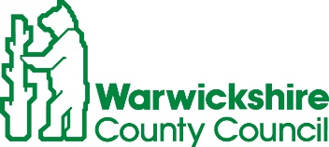
ROAD TRAFFIC REGULATION ACT 1984, SECTION 14
TEMPORARY CLOSURE OF COUGHTON FIELDS LANE, COUGHTON
Warwickshire County Council has made a Temporary Traffic Order details as indicated below:
Effect of Order | Coughton Fields Lane closed to vehicular traffic between its junctions with B4089 and A435 Birmingham Road.
Reason for Order | To enable works for a new clean water connection.
Order Effective from: 21 February 2022 for up to 18 months or until works are completed, whichever is the sooner.
Anticipated Completion Date: 23 February 2022.
Access & Diversion: An alternative route will be signed and is available via Coughton Fields Lane, Captains Hill, Kinwarton Road, Kinwarton Farm Road, Tything Road West, Arden Road, Birmingham Road and vice versa.
Vehicular access & egress will be maintained where possible.
Contractor: For Severn Trent Water, Go Traffic Management Ltd Tel: 0800 783 4444.
To report any problems with these works or for further details of our current & planned roadworks visit our website www.warwickshire.gov.uk/roadworksmap or call us 01926 412515.
S Duxbury, Assistant Director of Governance & Policy,
17 February 2022

