AGENDA

Annual Assembly
of Coughton Parish Council
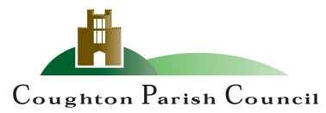

Date and time: Monday 18th March 2024 at 6:30pm
Place: Coughton C of E Primary School

The Chair and Members of the Parish Council cordially invite you to attend the Annual Parish Assembly to be held at Coughton C of E Primary School, Coughton on Monday 18th March 2024 at 6:30pm.

R Piddington
Cllr Roy Piddington
Chair - Coughton Parish Council

MEMBERS OF THE PUBLIC AND PRESS ARE WELCOME TO ATTEND

- WELCOME and APOLOGIES

- CONFIRMATION OF MINUTES
To approve the minutes of the meeting held on 15th May 2023 DOCUMENT 1

- THE PARISH COUNCIL YEAR
To receive a report from Cllr Piddington

- COMMUNITY REPORTS DOCUMENT 2
- County Councillor Justin Kerridge
- District Councillor Susan Juned
- Ros Anscombe – Heart of England Forest
- Simon Pickering – National Trust
- MATTERS RAISED BY THE ELECTORATE

Sarah Whittaker
Parish Clerk
coughtonclerk@gmail.com
www.coughtonparishcouncil.co.uk

