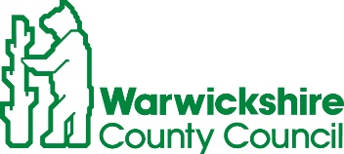
ROAD TRAFFIC REGULATION ACT 1984, SECTION 14
TEMPORARY CLOSURE OF COUGHTON LANE, COUGHTON
Warwickshire County Council has made a Temporary Traffic Order details as indicated below:
Effect of Order | Coughton Lane closed to vehicular traffic.
Reason for Order | To enable works for the renewal of a water pipe.
Order Effective from: 11 April 2022 for up to 18 months or until works are completed, whichever is the sooner.
Anticipated Completion Date: 14 April 2022
Access & Diversion:
An alternative route will be signed and is available via Coughton Lane, Alcester Heath, Birmingham Road and vice versa.
Vehicular access & egress will be maintained where possible.
Contractor: For Severn Trent Water, Chevron TM Tel: 0800 783 4444.

To report any problems with these works or for further details of our current & planned roadworks visit our website www.warwickshire.gov.uk/roadworksmap or call us 01926 412515.
S Duxbury, Assistant Director of Governance & Policy,
Shire Hall, Warwick, CV34 4RL.
7 April 2022

