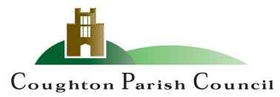

AGENDA
Ordinary Meeting
of Coughton Parish Council

Date and time: Monday 25th July 2023
Place: Coughton C of E Primary School

Dear Councillor
You are hereby summoned to attend an Ordinary meeting of the Parish Council to be held Coughton C of E Primary School on Monday 25th July 2023 at 6:30pm.

S.Whittaker

Sarah Whittaker – Clerk to Coughton Parish Council

MEMBERS OF THE PUBLIC AND PRESS ARE WELCOME TO ATTEND

- WELCOME & APOLOGIES

- DECLARATIONS OF INTEREST

- PUBLIC PARTICIPATION

- APPROVAL OF MINUTES
To approve the minutes of the meeting held on 15th May 2023

FINANCIAL MATTERS

EMAILED
- RFO Report
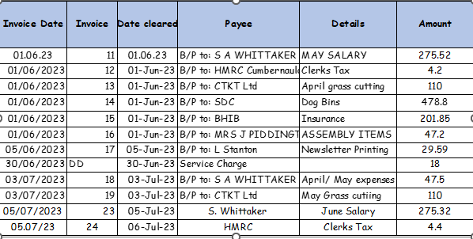

- PREVIOUS ACTION POINTS
AP1/Jan Agreed that Cllr Carter would further investigate the fishing rights licence and report back to the council ONGOING.

- VILLAGE REPORTS
- Environment Group
- Community Group
- Coughton C of E Primary School
- Roads and pathways

- PLANNING

- COUNTY COUNCILLOR J. KERRIDGE
To receive a verbal report.

- DISTRCIT COUNCILLOR S. JUNED
To receive a verbal report

- CORRESPONDENCE

- COUNCILLOR’S REPORTS and ITEMS FOR FUTURE AGENDAS

- VILLAGE CHAMPION AWARD

- DATE OF NEXT MEETING
- 25^{h} September 2023 at 6:30pm

Sarah Whittaker
Parish Clerk
coughtonclerk@gmail.com
www.coughtonparishcouncil.co.uk

