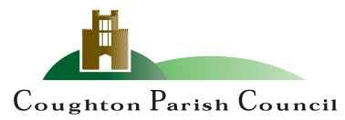

AGENDA
Annual Meeting
of Coughton Parish Council

Date and time: Monday 18th March 2024
Place: Coughton C of E Primary

Dear Councillor
You are hereby summoned to attend the Annual Meeting of the Parish Council to be held Coughton C of E Primary School on Monday 18th March 2024 at 7:00pm.

S.Whittaker

Sarah Whittaker – Clerk to Coughton Parish Council

MEMBERS OF THE PUBLIC AND PRESS ARE WELCOME TO ATTEND

- WELCOME & APOLOGIES

- DECLARATIONS OF INTEREST

- PUBLIC PARTICIPATION

- APPROVAL OF MINUTES
To approve the minutes of the annual meeting held on 15th May 2023 and the ordinary meeting held on 22nd January 2024.
- ELECTION OF CHAIR

- DECLARATION OF ACCEPTANCE
Chairman to sign the Declaration of Acceptance

- ELECTION OF VICE CHAIR
Vice Chair to sign the Declaration of Acceptance

- DECLARATION OF ACCEPTANCE

- AREAS OF RESPONSIBILITY
To agree Parish Councillors areas of responsibility
Current responsibilities are:
- Risk Assessments – Cllr Lewington
- Planning –ALL COUNCILLORS
- Defibrillator – Cllr Piddington/Cllr Stanton
- Employment/HR – Cllr Piddington/Cllr Lewington
- Communications – Cllr Stanton
- Flooding – Cllr Stanton
- Community Group – Cllr Stanton
- Finance – Cllr Carter
- Environment Group (incorporating Trees and Ford group)– Cllr Lewington

- GOVERNANCE EMAILED
To agree the following:
- Financial Regulations
- Standing Orders
- Code of Conduct

FINANCIAL MATTERS

EMAILED
- RFO Report DOCUMENT 1
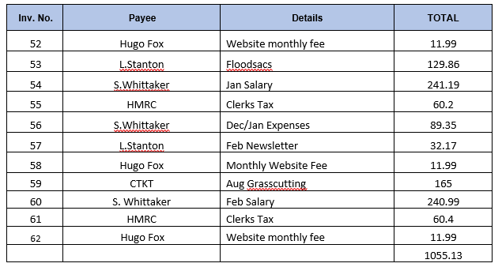

- To approve the purchase of gov.uk domain names for parish council website and Clerk and Councillor email addresses.
- To agree the purchase of speeding and litter signs for the village.
- To approve a donation to Alcester First Responders for the recent defibrillator training.
- Agree repurchase of Parish bin near Ford at a cost of - £250 +VAT Installation is £150 +VAT

- CHANGE OF MEETING DATE AND EXTAORDINARY MEETING DATE
To agree the changed meeting dates for May and July due to the school being closed for holidays. An extraordinary meeting date will need to be agreed prior to Friday 31st May 2024 as the internal audit visit is agreed for this date.

- PREVIOUS ACTION POINTS
AP5/July Agreed to arrange a multi-agency meeting regarding the speeding particularly by the school on the A435. Letter received from WCC via Nadim Zawahi which was read at the meeting. There was disappointment expressed at the lack of action from the County Council and alternatives were discussed such as banning the parking of cars in the immediate vicinity of the school but there were no safe or financially viable alternatives. ONGOING

- D DAY 80TH ANNIVERSARY VILLAGE REMEMBERANCE
To agree the Parish Council Celebrations to commemorate the event.

- FLOOD RELIEF PROPOSALS
To discuss proposals from Cllr Kerridge

- VILLAGE REPORTS

- COUNCILLOR’S REPORTS and ITEMS FOR FUTURE AGENDAS

- DATE OF NEXT MEETING
- 3rd June 2024 at 6:30pm

Sarah Whittaker
Parish Clerk
coughtonclerk@gmail.com
www.coughtonparishcouncil.co.uk

