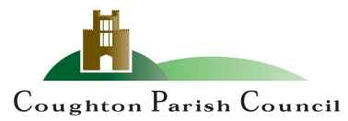

AGENDA
Extraordinary Meeting
of Coughton Parish Council

Date and time: Monday 27th June 2022
Place: Coughton C of E Primary

Dear Councillor
You are hereby summoned to attend an Extraordinary Meeting of the Parish Council to be held Coughton C of E Primary School on Monday 27th June at 6.30pm.

S.Whittaker

Sarah Whittaker – Clerk to Coughton Parish Council

MEMBERS OF THE PUBLIC AND PRESS ARE WELCOME TO ATTEND

- WELCOME & APOLOGIES

- DECLARATIONS OF INTEREST

- PUBLIC PARTICIPATION

APPROVAL OF MINUTES
To approve the minutes of the annual meeting held on 23rd May 2022.

FINANCIAL MATTERS
- RFO Report DOCUMENT 1
- Internal Audit Report DOCUMENT 2
- Annual Governance & Accountability Return 2021/2022 DOCUMENT 3
- Agree annual governance statement
- Agree accounting statements 2021/2022

- COUNCILLOR’S REPORTS and ITEMS FOR FUTURE AGENDAS

- DATE OF NEXT MEETING
- 25th July 2022 at 6.30pm

Sarah Whittaker
Parish Clerk
coughtonclerk@gmail.com
www.coughtonparishcouncil.co.uk

