Coughton Parish Council 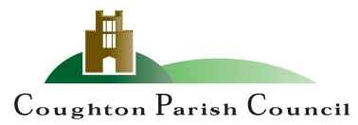
Financial Report 15th July 2024
Payments
Inv. No. | Payee | Details | TOTAL
25 | GoCardless | Hugo Fox Website monthly fee | 11.99
26 | Unity Trust | Service Charge | 18
27 | HMRC | Clerks Tax | 60.40
28 | W. Robinson | Internal Audit Fee | 279.60
29 | S. Whittaker | Clerks Salary | 240.99
30 | SDC | Bin Emptying | 513
 |  | TOTAL | 1154.61

Bank Reconciliation July 2024
Opening Bank Balance 01/04/24 | 3,325.82
Plus Receipts | 3315.5
Minus Payments | 3,475.10
TOTAL | 3,166.22
Plus uncleared payments: | 0.00
 | 3166.22

Receipts
Date Rec'd | Receipt No. | Payee | Details | TOTAL
25/04/2024 | 1 | Stratford DC | Precept | 3,315.50

]

