Minutes
Annual Parish Meeting
of Coughton Parish Council


Date and time: Monday 24th July 2023 at 6:30pm
Place: Coughton C of E Primary School, Coughton Lane

Present: Cllr R. Piddington, Cllr L. Carter, Cllr Stanton and Cllr Lewington
In attendance: Sarah Whittaker (Parish Clerk) District Councillor Susan Juned, Mr Kolb (Headteacher) and 4 members of the public.

230/23 WELCOME AND APOLOGIES
Apologies were received from County Councillor Justin Kerridge, the apologies were accepted.

231/23 DECLARATIONS OF INTEREST
None declared.

232/23 PUBLIC PARTICIPATION.
Local residents reported how dangerous the footpath opposite the Throckmorton had become. When walking with dogs it is dangerously overgrown and a hazard as it results in people walking in the road. Residents have tripped into the road because of the hazards from the hedge. Some discussion followed about whether it is it owned by National Trust or responsibility of Highway. District Councillor Juned suggested contacting the County Council who can use powers to enforce landowners to manage hedges. AP1 Clerk to contact National Trust and County Council. Mr Kolb suggested inviting the national trust to the meetings to discuss in person as issues may get lost in other emails.
A resident queried the response from the Chairman speaking to a staff member at the nursery about parking. The nursery had agreed to speak to the member of staff, however the Manager at the nursery pointed out that it was legal to park the car on the road, although it agreed it did cause disruption.
Residents asked about work commencing at the Stackyard/Rickyard. The Clerk had received a response and the National Trust said they would inform the council when any work would commence. AP2 – Clerk to check when planning permission runs out at the Stackyard and report back. There were questions asked about when the new bench will be cited at the Ford. Cllr Lewington explained that the ford area needs reporting as there was a considerable debris gathering around the bridge etc. Agreed that Cllr Stanton will send photos to councillors.

233/23 APPROVAL OF MINUTES
Cllr Lewington asked Village reports change to less people for the cemetery clear up. Once amended it was proposed by Cllr L. Stanton and seconded by L. Carter to approve the minutes.

234/23 FINANCIAL MATTERS

EMAILED
- RFO Report DOCUMENT 1

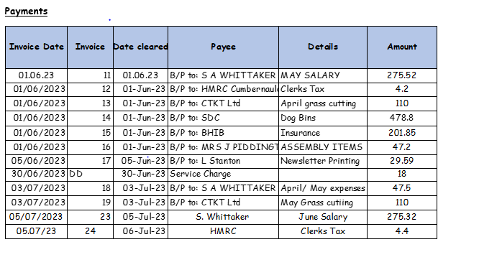
Proposed by Cllr L. Carter and seconded by Cllr C. Lewington to authorise all payments listed.

235/23 ACTION POINTS
AP1/Jan Agreed that Cllr Carter would further investigate the fishing rights licence and report back to the council ONGOING

236/23 VILLAGE REPORTS
- Environmental Group
Nothing to report.
- Community Group
There was the second successful choir concert raising over £2000 with over £1000 going to the Dementia Café and £1000 to Greig Hall.
- Coughton C of E Primary School
Almost at the end of the school year, numbers are the same. Cllr Lewington queried the possibility of funding for the decking due to a shortfall. A request had been submitted to the Community Fund, but no money had been received at present. AP3 Cllr Lewington agreed to chase this with the Community Fund.
- Roads and pathways
Cllr Stanton was still awaiting repairs on roads locally by highways, that have been reported. AP4 - Clerk to send a letter to the National Trust outlining the black bags which had been reported to the police as it was believed to contain drugs. Cycle lines still need to be reinstated on the A435 and Sambourne Lane, which have previously been reported.

237/23 PLANNING

All received planning applications, approvals and refusals were discussed. No objections received.
A resident had pointed out that there were some trees overhanging on the school grounds on the corner of the A435. Mr Kolb reported that works were impending as part of the listed planning works.

238/23 REPORT FROM CLLR KERRIDGE
In his absence County Councillor Kerridge emailed a report:
Please do make the flood group aware of my continuing interest in putting a case together to WCC detailing flooding occurrence and sources of flooding and thus to make the case for any mitigation Warwickshire County Council may be able to fund or seek funding for. I hope to send a copy of the Redditch to Alcester off road cycle path feasibility study soon.
This will be in confidence, for Cllrs only until land owners along potential routes have been contacted. At that point a public open day can be organised, hopefully later this year. But I wanted the PC to have sight of it ASAP. This is only the start of what, if it does happen, will take many years to complete.

239/23 REPORT FROM CLLR SUSAN JUNED
Warwickshire County Council had proposed to become part of Birmingham Combined Authority without any consultation, which would have resulted in a large charge by joining. The County Council transport budget would be absorbed into the BCA budget with far reaching implications. The plan was for this to originally happen before the May 2024 elections. 5 District Councils raised concerns about lack of consultation and has now been withdrawn. There are some changes in the law which are currently going through parliament and the combined authorities may well come back in May 2025/26, so legalities need to be considered.
The council are now looking at a new council plan and consulting with council members and will feed down to parish councils and members of the public. The reviewed local plan is going through, with options and consultations about various cycle paths and new housing in the district. The council has to meet by law a certain number of houses and liase with local surrounding councils. Trying to keep amount to the lowest possible but there are more consultations to be had.
Cllr Juned reported that there was debate about the viability of Ubus, which is often used by County Council users for hospital trips etc but funded by district council. There was the possibility of Warwickshire County Council helping with funding.
Cllr Juned was hoping to have a Community Climate Change Grant Fund to enable communities to tackle climate change i.e. solar panels on village halls or insulation. Available for all communities to apply for. Information should be available by September/October. Cllr Juned was currently engaged with a local group for off road cycling from Evesham, due to the proposed cycle paths from Stratford using old railway tracks and pathways. A resident asked around the timescales of the proposal and it was hoped that it could be within 2 years. Cllr Juned reported that she had thoroughly enjoyed the fete and particularly praised the choir performance. Mr Kolb praised the work of Cllr Juned especially around sustainability and encouraged the parish council to get involved.

240/23 CORRESPONDENCE
A resident had written to the council regarding drains and potholes hit by lorries resulting in increased noise and increased traffic from Redditch Gateway. AP5 Agreed that Cllr Stanton will report to Highway and will also be part of the meeting and discussions with highways councils and councillors
Mr Kolb informed the council that through the school’s work with Safe and Active travel works that the A435 has been recategorized as a high-risk road. Money has been ploughed into number plate recognition on cameras. L. Stanton reports the big gap between the speed cameras. Parents at the school reported that there were some drivers that weren’t stopping at the pedestrian crossing by the school or breaking too late. AP6 Request a meeting with the County Council and request District Cllr Juned to attend and Mr Kolb. Cllr Kerridge may have funding available to fund some preventative work. Clerk to email Justin Kerridge to arrange a meeting.

241/23 COUNCILLORS REPORT
Nothing to report.

242/23 VILLAGE CHAMPION AWARD
Postponed to next meeting to drum up more interest.

243/23 DATE OF NEXT MEETING
- 25th September 2023 at 6:30pm.
Proposed by Cllr Stanton and seconded by Cllr Lewington. District Cllr Juned sent her apologies for the next meeting.

The meeting was closed at 7.28pm Proposed by L. Stanton and seconded by Cllr Lewington.

Sarah Whittaker
Parish Clerk
coughtonclerk@gmail.com

